|  |
| --- |
| Module 1: Introduction To MongoDB – Architecture & Installation |

Case Study 1

1. Business Requirement :

* Database solution to enable business innovation, reduces costs, accelerates time to market, transforms customer experience, and enhances efficiency
* Data obtained from various data sources is in structured, semi-structured, or unstructured format
* Heavy queries immensely affect the database performance

1. Compare different database categories :

1. Oracle

Pros

You’ll find the latest innovations and features coming from their products since Oracle tends to set the bar for other database management tools.

Oracle database management tools are also incredibly robust, and you can find one that can do just about anything you can possibly think of.

Cons

The cost of Oracle can be prohibitive, especially for smaller organizations.

The system can require significant resources once installed, so hardware upgrades may be required to even implement Oracle.

Ideal for: Large organizations that handle enormous databases and need a variety of features.

2. MySQL

Pros

It’s available for free.

It offers a lot of functionality even for a free database engine.

There are a variety of user interfaces that can be implemented.

It can be made to work with other databases, including DB2 and Oracle.

Cons

You may spend a lot of time and effort to get MySQL to do things that other systems do automatically, like create incremental backups.

There is no built-in support for XML or OLAP.

Support is available for the free version, but you’ll need to pay for it.

Ideal for: Organizations that need a robust database management tool but are on a budget.

3. Microsoft SQL Server

Pros

It is very fast and stable.

The engine offers the ability to adjust and track performance levels, which can reduce resource use.

You are able to access visualizations on mobile devices.

It works very well with other Microsoft products.

Cons

Enterprise pricing may be beyond what many organizations can afford.

Even with performance tuning, Microsoft SQL Server can gobble resources.

Many individuals have issues using the SQL Server Integration Services to import files.

Ideal for: Large organizations that use a number of Microsoft products.

4. PostgreSQL

Pros

This database management engine is scalable and can handle terabytes of data.

It supports JSON.

There are a variety of predefined functions.

A number of interfaces are available.

Cons

Documentation can be spotty, so you may find yourself searching online in an effort to figure out how to do something.

Configuration can be confusing.

Speed may suffer during large bulk operations or read queries.

Ideal for: Organizations with a limited budget that want the ability to select their interface and use JSON.

5. MongoDB

Pros

It’s fast and easy to use.

The engine supports JSON and other NoSQL documents.

Data of any structure can be stored and accessed quickly and easily.

Schema can be written without downtime.

Cons

SQL is not used as a query language.

Tools to translate SQL to MongoDB queries are available, but they add an extra step to using the engine.

Setup can be a lengthy process.

Default settings are not secure.

6. MariaDB

Pros

The system is fast and stable.

Progress bars let you know how a query is progressing.

Extensible architecture and plug-ins allow you to customize the tool to match your needs.

Encryption is available at network, server and application levels.

Cons

The engine is still fairly new, so there’s no guarantee further updates and versions will be forthcoming.

As with many other free database engines, you have to pay for support.

Ideal for: Organizations looking for an affordable MySQL alternative.

7. DB2

Pros

Blu Acceleration can make the most of available resources for enormous databases.

It can be hosted from the cloud, a physical server or both at the same time.

Multiple jobs can be run at once using the Task Scheduler.

Error codes and exit codes can determine which jobs are run via the Task Scheduler.

Cons

The cost is outside of the budget of many individuals and smaller organizations.

Third party tools or additional software is required to make clusters or multiple secondary nodes work.

Basic support is only available for three years; after that, you have to pay for it.

Ideal for: Large organizations that need to make the most of available resources and handle large databases

8. SAP HANA

Pros

It supports SQL, OLTP and OLAP.

The engine reduces resource requirements through compression.

Data is stored in memory, reducing access times, in some cases, significantly.

Real-time reporting and inventory management are available.

It can interface with a number of other applications.

Cons

The licensing cost is high for SAP HANA even for those used to paying for enterprise software.

SAP HANA is still a relative newcomer, and patches and updates are frequent to the point of being annoying.

Ideal for: Organizations that are pulling data from applications and aren’t under a terribly constrained budget

1. Select a database from the category which caters to the business needs :

* We can select MongoDB as the data source are expected to be structured, semi-structured as well as unstructured formats
* The Database performance would be free from heavy SQL queries and hence faster in production
* Installation would also be faster to help developer’s work on their projects quickly

1. Install the database

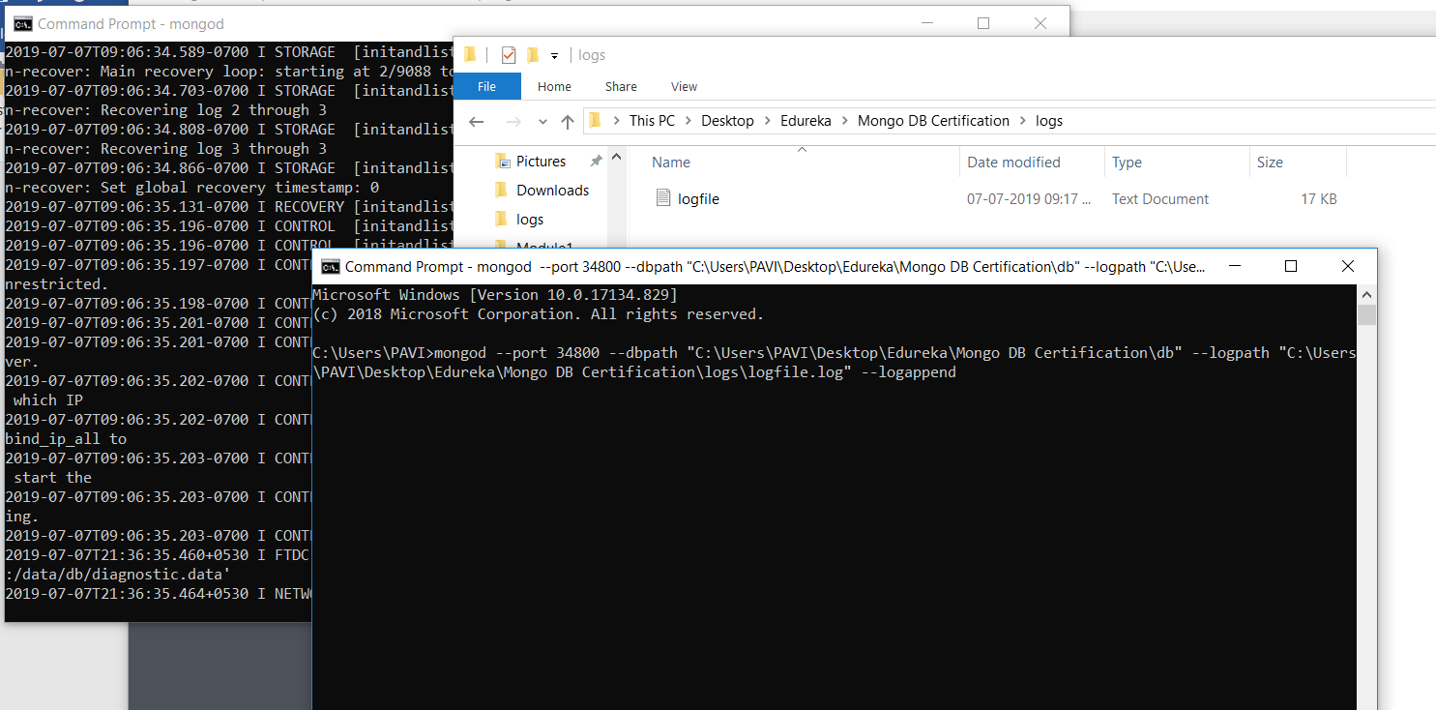

1. Explore the database

Starting the Mongodb server:

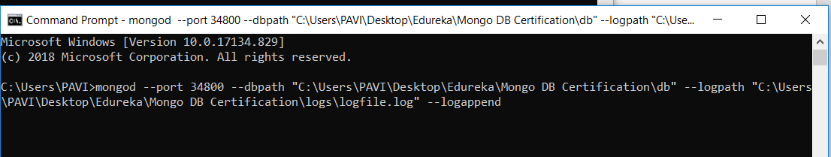

Calling server using default mongo client:

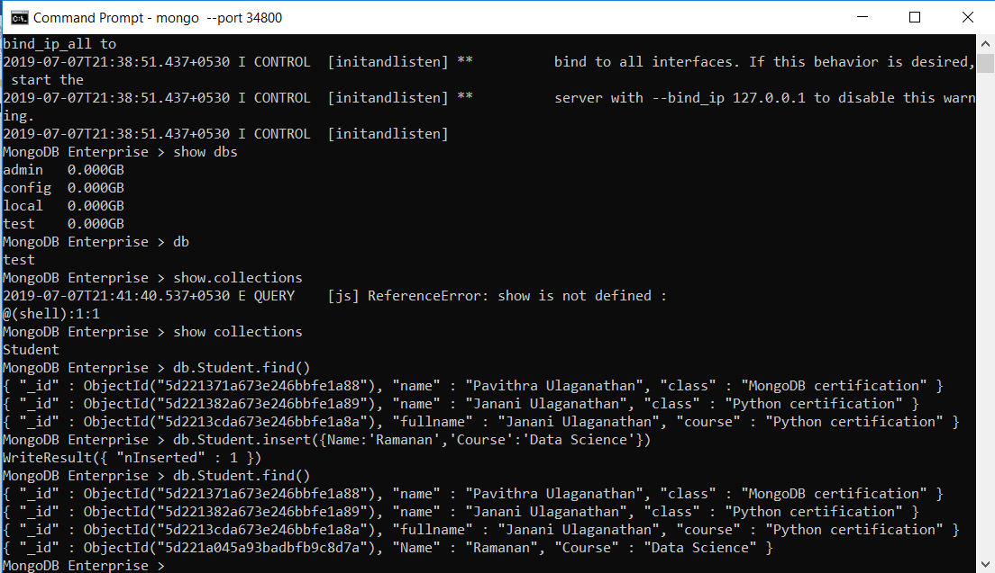

Mongodb compass GUI:

